Industry Resource Toolkit series:
Australia’s national biosecurity system

How to use this resource
This article is the first in an educational series aimed at providing Plant Health Australia’s Plant Industry Members with a resource toolkit containing information on national response arrangements under the Emergency Plant Pest Response Deed (EPPRD).

This article and the accompanying resources recognises you as the national peak industry body and signatory to the EPPRD, and your role as your industry's representative during a response to an Emergency Plant Pest (EPP).

Throughout the articles, you will find sections that can be tailored to make it more relevant to your members or industry and we encourage you to highlight how your organisation supports its members. This information can be used to create content for your website, social media, newsletters, videos, podcasts, webinars, or other formats and both long-form and short-form content is provided to help you adapt it to the relevant platform. You can also incorporate this material into your member training and educational programs.

Before you publish:
When adapting the articles, it is important to maintain factual accuracy and sequential order. Many of the concepts explained throughout the toolkit rely on using correct terminology to avoid providing inaccurate or misleading information. We request that you:
- publish the articles in the correct order to allow readers to build on their knowledge from one article to the next
- include the following statement indicating that it has been developed in collaboration with Plant Health Australia:
This content has been developed in collaboration with Plant Health Australia to increase awareness of national response arrangements under the Emergency Plant Pest Response Deed (EPPRD).

Industry organisations outside of Plant Health Australia’s Plant Industry Members are welcome to publish the information, provided the articles acknowledge the national peak industry body as the representative body under the EPPRD.

Find out how to use the toolkit articles to provide information to your members.

Growers and producers are encouraged to contact their national peak industry body for further information.

Long-form content
This section provides detailed information about Australia's national biosecurity arrangements, with a focus on exotic plant pests and diseases under the Emergency Plant Pest Response Deed (EPPRD). This content is best suited for websites, blogs, newsletters, podcasts, video scripts, or other long-form content. The information under each heading allows you to use the content as is or tailor it to your industry. You're encouraged to adapt the style and tone of the content to fit your communication style.

Australia’s national biosecurity system
In this article, you will learn about Australia’s national biosecurity system and how we respond to emergency plant pest (EPP) incidents, including:
- what is being done to protect Australia from exotic plant pests and diseases
- our national plant biosecurity arrangements
- the role growers play in our national plant biosecurity system.

Key points
- Keeping Australia’s plant industries free of unwanted exotic pests and diseases is an ongoing process undertaken overseas, at our border, and within Australia and our external territories.
- Growers can actively participate in our national plant biosecurity system by implementing good biosecurity practices, monitoring their property for unusual pests, and reporting suspected exotic pests and diseases.

Australia’s national plant biosecurity system
Australia is free from many pests and diseases that in other parts of the world have severely impacted crop production, natural environments and communities. Australia has a world-class plant biosecurity system that works hard to protect our lifestyles, natural environment and livelihoods.
The national plant biosecurity system includes activities overseas, at our borders, and within Australia. Protecting Australia from pests and diseases is only possible when everyone works together and every Australian has a role to play.
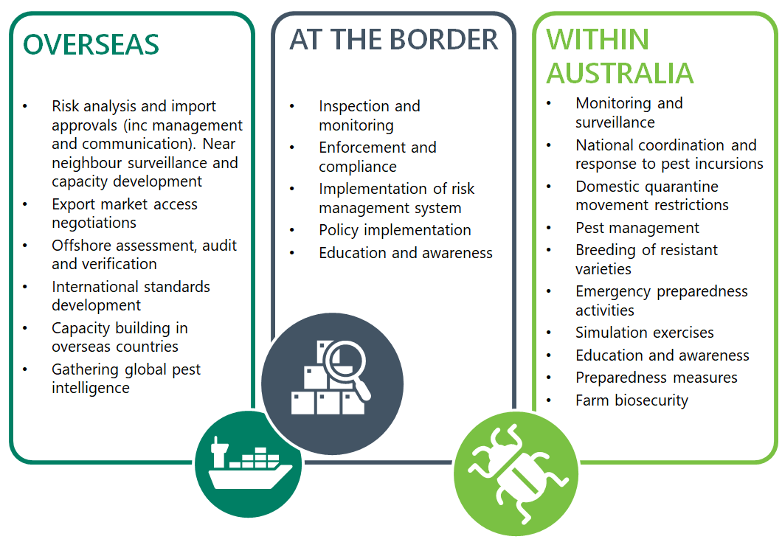

Image caption: Protecting Australia from plant pests and diseases through activities undertaken overseas, at our borders, and within Australia.

The image above shows the activities undertaken overseas, at our borders, and within Australia. It is available in the graphics pack for Article 1. You can customise the graphic to suit your organisation’s branding and use the image for your communications channels.

Overseas and at the border
The Department of Agriculture, Fisheries and Forestry works to minimise the likelihood of pests and diseases entering the country pre-border and at the border. Their role is to coordinate national biosecurity policy to reduce the risk of pest entry into Australia and carry out quarantine inspections at the border.
Pre-border activities undertaken in Australia and overseas include:
- undertaking risk analyses on the likelihood of imported goods hosting exotic pests and diseases
- issuing import approvals to companies and individuals who have met our import requirements
- developing international standards that our trading partners must maintain when importing goods into Australia
- gathering intelligence on global pests that require monitoring
- working with our trading partners to develop agreements to allow our producers to export their goods to international markets.
At border activities undertaken at Australian ports and other authorised quarantine premises include:
- inspecting and if needed treating goods, equipment and vehicles entering the country for unwanted pests and diseases
- inspecting people and their luggage for unauthorised goods and those that may be carrying unwanted pests and diseases
- prioritising exotic pests with targeted inspection and monitoring activities
- educating incoming passengers about the importance of biosecurity.

Within Australia
Within Australia, prevention and detection is the role of every Australian and we all have a responsibility to report unusual pests and diseases.
Activities undertaken within Australian borders include:
- ongoing surveillance for pests and diseases
- movement restrictions on certain high risk plant material to stop the spread of pests and diseases
- preparing for a biosecurity emergency through education and planning
- an agreed national coordination strategy when responding to pest and disease incursions.
The Australian government, state and territory governments and industry actively work together to reduce the risks of exotic pests and diseases impacting Australia.

Responding to a national biosecurity incident
Australia’s biosecurity system is robust, but it is not infallible. When a plant pest or disease biosecurity incident does occur, it is managed through a partnership agreement between the Australian government, state and territory governments, national plant industry bodies and Plant Health Australia.
An essential part of our biosecurity system is being able to respond effectively to eradicate or contain a pest or disease. In Australia we have established agreements to support national response measures to pest and disease detections, increasing the likelihood of successful containment and eradication.

What are the ’arrangements’?
Response arrangements are agreements between parties that outline decision making and cost-sharing arrangements to enable a coordinated, effective and efficient response.
There are three national biosecurity response agreements in Australia:
- The Emergency Plant Pest Response Deed (EPPRD). The Australian government, all state and territory governments and peak plant industries are signatories. The EPPRD covers exotic insects, mites, pathogens (disease), nematodes and snails that have potential to impact on our crop, bee, and edible fungi industries. Plant Health Australia is the custodian.
- The Emergency Animal Disease Response Agreement (EADRA): The Australian government, all state and territory governments and peak animal industries are signatories. The EADRA covers diseases that have a significant impact on livestock. Animal Health Australia (AHA) is the custodian.
- The National Environmental Biosecurity Response Agreement (NEBRA) is an agreement amongst government signatories and covers pests that impact our environment and way of life. Non-government entities may participate in incidents covered by the NEBRA on an incident-by-ident basis, subject to the requirements of the agreement. The custodian is the Department of Agriculture, Fisheries and Forestry.
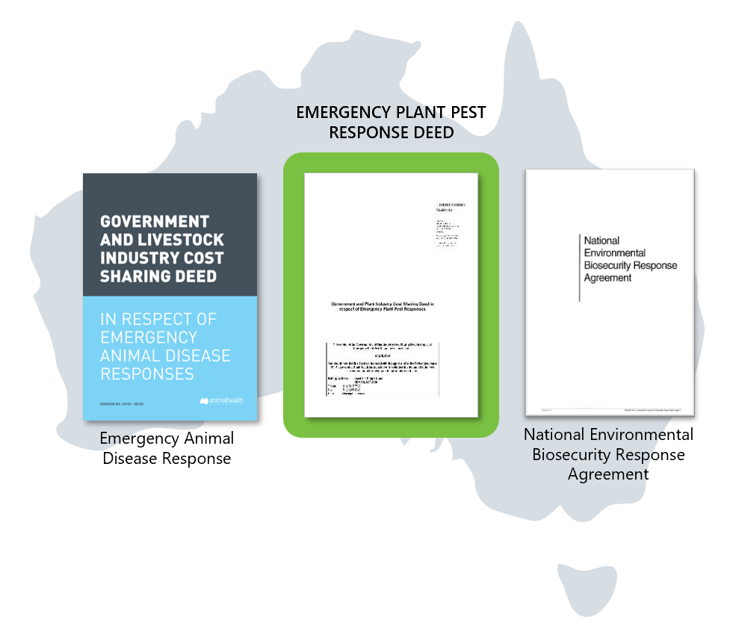

Image caption: There are three national biosecurity response agreements in Australia

The image above shows the three national biosecurity response agreements in Australia. It is available in the graphics pack for Article 1. You can customise the graphic to suit your organisation’s branding for your communications channels.

Emergency Plant Pest Response Deed
So, what is the EPPRD? In short, it:
- is a legally binding agreement between the signatories which (as at [insert date article is published]) are the Australian government, all the state and territory governments, 37 national plant industry bodies and Plant Health Australia
- outlines the shared role signatories play in managing and funding emergency responses
- ensures there is accountability and transparency in decision making
- outlines the potential for growers who are affected by response actions to be reimbursed for defined losses and costs
- commits all signatories to implement processes to reduce the risk of a biosecurity incident and maintain trained personnel, technical expertise and capacity to respond.
If you are publishing the toolkit articles on your website, remember to update this section to link to Article 3: ‘Responding to an emergency plant pest under the EPPRD’. Check the Plant Health Australia website for the latest version of the EPPRD to ensure your content is current.

What is an Emergency Plant Pest?
Any pest or disease that isn’t native to or established in Australia may be considered exotic. However those exotic pests and diseases with the potential to cause significant damage across Australia’s primary production, environmental or amenity landscapes are considered an Emergency Plant Pests (EPP). This is also relevant for pests and diseases that may affect European Honey Bees (Apis mellifera), which many of Australia’s plant industries rely on for pollination of different plants.
Determining whether a pest or disease is an EPP is important as the EPPRD is only applied where the pest or disease has been identified as an EPP. If an exotic pest doesn’t meet the criteria of an EPP, it doesn’t signify inaction allowing it to become established. The state or territory where the pest is detected may work with their industries to eradicate the pest in order to retain their proof of freedom for market access. However, this work is not carried out under a national coordinated response plan.
In brief, for an exotic pest or disease to be identified as an EPP, it must have a nationally significant impact, whether economically or environmentally, and must also meet one or more of the following criteria:
- a known plant pest not previously detected (or previously eradicated) in Australia
- a variant form of an established plant pest that can be distinguished by appropriate investigative and diagnostic methods
- a newly identified plant pest of unknown or uncertain origin
- a plant pest already found in Australia that:
  - is restricted to a defined area through regulatory measures to prevent further spread of the pest; and
  - has been detected outside the defined area; and
  - is not a native of Australia; and
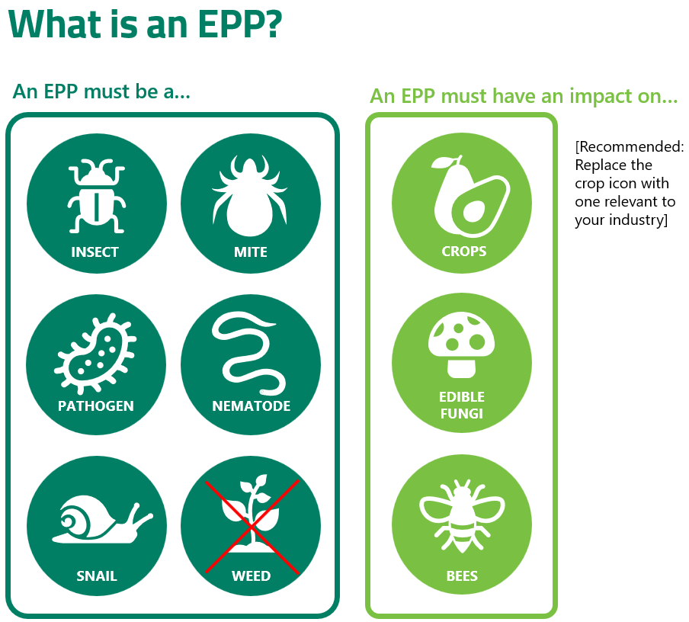
  - is not the subject of any instrument for management which is agreed to be effective risk mitigation and management at a national level.
Image caption: The EPPRD is only applied where the pest or disease has been identified as an Emergency Plant Pest.

The diagram above depicts what an Emergency Plant Pest is. It is available in the graphics pack for Article 1. You can customise the graphic to suit your organisation’s branding and use the image for your communications channels. It is recommended you replace the crop icon with one relevant to your industry. Note: this diagram can also be used in Article 3: ‘Responding to an emergency plant pest under the EPPRD.

Role of growers in the national biosecurity system
In this section, you are encouraged to tailor content to your industry. Consider adding information about the following:
- How your national peak industry body collaborates with its members to aid them in their role within the national biosecurity system.
- Explain how your members can actively participate in the national system.
As a grower, you play a key role in protecting Australia's agricultural industries from pests and diseases by detecting potential threats and decreasing the risk of a new plant pest or disease entering and establishing on your property.

Minimising biosecurity risks
There are actions you can take every day to minimise the risk of plant pests and diseases entering and establishing on your property. Prevention, as they say, is better than a cure.
Here are a few simple ways you can keep your property pest-free:
- monitor people, vehicles and equipment that go on and off your property, making sure they are clean and free from dirt and weeds
- implement good farm hygiene practices such as controlling weeds and feral animals, monitoring water sources, using and storing chemicals according to their labels, and keeping production and storage areas clean and tidy
- make biosecurity a part of your day-to-day business by educating yourself and your staff on how to implement good biosecurity practices

Report anything unusual
All states and territories have a legal obligation requiring you to report potential biosecurity risks as soon as possible. The Exotic Plant Pest Hotline 1800 084 881L will link you directly to the state or territory agriculture department in the location you are calling from and advise you on the next steps. Reporting early is critical in increasing our chance of eradication and supporting a return to business as usual as quickly as possible.

What you can do now
- Familiarise yourself with the high-priority pests for [your industry]. Visit Plant Health Australia’s resource centre to find out more.
- Prepare a biosecurity plan for your property.
- Learn more about what happens when you report a suspected plant pest or disease (if you are publishing the articles on your website, link to the next article in this series)
- [Identify any programs or information you, as a national peak industry body, can provide to your members to support their understanding of your industry's role in the national biosecurity arrangements]

Add acknowledgement statement: This content has been developed in collaboration with Plant Health Australia to increase awareness of national response arrangements under the Emergency Plant Pest Response Deed (EPPRD).

Resources

Read: Want to learn more?
- Emergency Plant Pest Response Deed
- Emergency Plant Pests
- National Biosecurity Strategy

Watch: View videos online to find out more
- Australia’s Biosecurity system
- Department of Agriculture, Fisheries and Forestry’s Detect and Protect podcast series
- Biosecurity Bite: At the Border

Learn: Free training available on BOLT
Free training is available on Biosecurity Online Training platform (BOLT). Register your free account to get started.
- Growers - Pest Reporting and Responses course
If you are publishing the toolkit articles on your website, encourage your members to read more in Article 2: ‘What happens when you report something unusual?’ and Article 3: ‘Responding to an emergency plant pest under the EPPRD
If you are publishing the toolkit articles on your website, make sure you cross-link the information.

Short-form content
This section summarises the information contained in the article. This content is best suited for social media, newsletters, or other short-form content. You're encouraged to adapt the style and tone of the content to fit your communication style. Ensure you include the relevant organisations or governments social media handles if posting to your channels.

Australia’s national biosecurity system
Keeping Australia's plant industries free of unwanted pests and diseases is an ongoing process undertaken overseas, at and within our borders, including our external territories. Growers can actively participate in our national biosecurity system by implementing good biosecurity practices, monitoring their property for unusual pests and diseases, and reporting suspected exotic pests and diseases.
Suggestion: Use these points to highlight a specific article section in short-form messaging:
- Australia has a strong national biosecurity system that works to protect our environment, agricultural industries, communities and economy.
- Keeping Australia free of exotic pests and diseases is a continuous process undertaken overseas, at and within our borders, including our external territories.
- The Department of Agriculture, Fisheries and Forestry works pre-border with our international trade partners to minimise the likelihood of pests and diseases entering the country and at border to inspect and monitor incoming goods to ensure they meet our import requirements.
- As a grower, you can take an active role in our national biosecurity system by implementing good biosecurity practices, monitoring your property for anything unusual, and reporting suspect pests and diseases.
- If a plant pest or disease does enter Australia it is considered post-border and the management of an incursion is a partnership between the Australian government, state and territory governments, national plant industry bodies and Plant Health Australia.
- The Emergency Plant Pest Response Deed (EPPRD) is a formal agreement between the Australian Government, all state and territory governments, peak plant industry bodies and Plant Health Australia which guides the management and funding of responses to Emergency Plant Pests (EPP).
- An EPP is an exotic plant pest or disease that could have a significant national impact on our economy or environment and must meet specific criteria that are set out in the EPPRD.
- [Your peak national plant industry body name], as a signatory to the EPPRD, represents our growers during a biosecurity incursion by working with all affected parties to coordinate a national response to eradicate the EPP.

