

2022-23 Action Plan

National Plant Biosecurity Preparedness Strategy

# Acknowledgements

The *National Plant Biosecurity Preparedness Strategy 2022-2023 Action Plan* (Action Plan) was prepared by Plant Health Australia using funding provided by the Department of Agriculture, Fisheries and Forestry under the Plant Biosecurity Response Reform program.

Development of the Action Plan was guided by the National Plant Biosecurity Strategy Governance Group (Governance Group) which comprises representatives from the following:

* Department of Agriculture, Fisheries and Forestry
* Environment and Invasives Committee
* National Farmers’ Federation
* Plant Biosecurity Preparedness Working Group
* Plant Biosecurity Research Initiative
* Plant Health Australia
* Plant Health Committee
* Plant Industries Biosecurity Committee
* Subcommittee on National Plant Health Surveillance
* Subcommittee on Plant Health Diagnostics.

# Acronyms

|  |  |
| --- | --- |
| AFFTAC | Australian Fruit Fly Technical Advisory Subcommittee |
| EIC | Environment and Invasives Committee |
| HACCP | Hazard Analysis Critical Control Point |
| NECBRDES | National Environment and Community Biosecurity Research, Development and Extension Strategy |
| NEWP | National Established Weed Priorities |
| SDQMA | Subcommittee on Domestic Quarantine and Market Access |

# Introduction

The 2021-2031 National Plant Biosecurity Preparedness Strategy (the strategy) provides a framework to develop the capabilities required to prepare for and manage plant biosecurity risks across Australia.

The strategy outlines five interconnected goals to achieve the vision of a resilient plant biosecurity system that identifies and reduces risk and works to minimise the impact of biosecurity incidents to Australia’s plant industries, economy, environment and community.

Each goal is supported by a series of actions that guide and support national policy and inform investment in research, development and extension. The actions can also be used to guide state/territory, regional and local efforts or efforts by individual governments, plant industries and stakeholder groups.

The strategy acknowledges the importance of collective effort nationally to achieve the shared vision. This recognises biosecurity is a shared responsibility by all Australians, built on partnerships between governments, plant industries, natural resource managers, land custodians or users, and the community.

The National Plant Biosecurity Preparedness Strategy Implementation Plan (implementation plan) has been developed to support delivery of the strategy. The implementation plan complements the goals and actions in the strategy to provide more detail on implementation of these measures, including performance indicators and indicative timeframes for delivery.

# Purpose of the action plan

The Action Plan complements, supports and builds on the strategy and implementation plan in outlining the key activities from 1 July 2022 to 30 June 2023 that contribute to the delivery of the actions and expected outcomes.

The Action Plan also identifies the lead/champion[1] for each activity to provide transparency and accountability for stakeholders across the system.

This information plays an important role in establishing a framework for monitoring and evaluation while also helping to identify gaps and opportunities for collaboration across the system.

Progress against the Action Plan will be monitored and reviewed by the Governance Group to ensure national, regional and local effort against the strategy remains agile and responsive to changing priorities and a changing biosecurity context.

Annual evaluation reports will be developed to provide an update on implementation. These reports will be presented to various government and industry plant biosecurity committees and made publicly available.



## Expected outcome: Improved plant biosecurity preparedness delivery through collaborative partnerships between stakeholder groups nationally and internationally.

### ACTION 1.1:

### Establish a shared and agreed understanding of roles and responsibilities of stakeholders involved in the national plant biosecurity system

| **Activity** | **Lead/Champion** |
| --- | --- |
| Finalise a National Biosecurity Strategy and transition to action planning and implementation, in collaboration with state and territory governments, industry, environment and community  stakeholders. | Australian Government |
| Develop a biosecurity brand to increase awareness of the importance of biosecurity and people’s roles in the biosecurity system. | Australian Government |
| Deliver on the Northern Australia Biosecurity Strategy through its implementation plan. | Australian Government |
| Establish a co-funded National Established Weed Priorities (NEWP) facilitator and associated weeds coordinator roles to deliver NEWP outcomes. | Australian Government |
| Complete a mid-point review and finalise the implementation plan for the Australian Weeds Strategy 2017-2027. | EIC - Weeds Working Group |
| Promote the National Plant Biosecurity Preparedness Strategy and its achievements. | Plant Health Australia |
| Deliver awareness raising activities to develop a shared understanding of roles and responsibilities of stakeholders across the national fruit fly system. | Plant Health Australia |
| Develop a paper to clarify the ownership of the National Interstate Certification Assurance Program. | SDQMA |
| Finalise the Biosecurity Statement for Victoria and progress development of a Biosecurity Strategy for Victoria. | Victorian Government |

### ACTION 1.2:

### Establish ongoing forums for stakeholders to focus on plant biosecurity preparedness activities

| **Activity** | **Lead/Champion** |
| --- | --- |
| Establish a Northern Biosecurity Forum to plan and map out biosecurity threats, risks, innovations and approaches. | Australian Government |
| Deliver a virtual fora to provide an update on implementation of national action plans for Xylella and Khapra Beetle. | Australian Government |
| Deliver the Australian Biosecurity Webinar Series to enhance engagement and awareness across the system on priorities and challenges for biosecurity. | Australian Government |
| Deliver the 2022 Environmental Biosecurity Webinar Series to explore case studies, policies, initiatives and research from across the biosecurity system. | Australian Government |
| Deliver a forum to promote and support implementation of the National Environmental and Community Biosecurity Research, Development and Extension Strategy (NECBRDES). | NECBRDES National Coordinator |
| Deliver a series of online fora on high priority biosecurity topics to identify current and proposed research that may be the focus of co-investment. | Plant Biosecurity Research Initiative |
| Deliver biosecurity extension community meetings for extension practitioners to share knowledge and improve best practice across plant industries. | Plant Biosecurity Research Initiative |
| Establish a national network of plant biosecurity professionals to support pest risk decision-making processes underpinning market access assessments. | Plant Industries Biosecurity Committee |
| Establish a formal industry support mentor group through the Plant Industry Forum to support plant industries during a response. | Plant Industry Forum Committee |

### ACTION 1.3:

### Grow partnerships to prevent the entry of plant biosecurity threats and identify control and management options relevant to the Australian context

| **Activity** | **Lead/Champion** |
| --- | --- |
| Strengthen work with government, communities, industry, Indigenous groups, veterinarians and other service providers to raise awareness of biosecurity risks in the north. | Australian Government |
| Continue to work with New Zealand to increase our joint intelligence capacity (including concluding an intelligence-sharing arrangement). | Australian Government |
| Finalise the Pacific Biosecurity Strategy 2021-2026. | Australian Government |
| Support continued engagement and participation of Asian and Southwest Pacific region members to the International Plant Protection Convention, including regional standard setting and implementation. | Australian Government |
| Establish a cross-sector working group to identify and coordinate national RD&E priorities in collaboration with key stakeholders. | NECBRDES National Coordinator |
| Progress key activities under the memorandum of understanding between the Plant Biosecurity Research Initiative, Better Border Biosecurity (B3) New Zealand, Euphresco and the Australian Centre for International Agriculture Research. | Plant Biosecurity Research Initiative |
| Establish an ongoing partnership with the Plant Health Committee to advance the coordination of plant biosecurity research. | Plant Biosecurity Research Initiative |
| Deliver targeted workshops to shape global plant research partnerships. | Plant Biosecurity Research Initiative |
| Hold a joint workshop with the Plant Industries Biosecurity Committee to identify priority activities and build engagement with plant industries. | Plant Health Committee |
| Support regional fruit fly groups to ensure industry and stakeholder engagement. | South Australian Government |
| Deliver a series of symposiums and conferences to build connections, share research outcomes and exchange knowledge and ideas, including the:   * Australian Biosecurity Symposium * Australasian Plant Virology Workshop * Australasian Weeds Conference * Developing Northern Australia Conference * Hort Connections * International Plant Health Conference * International Symposium on Fruit Flies of Economic Importance * National Landcare Conference. | Various |

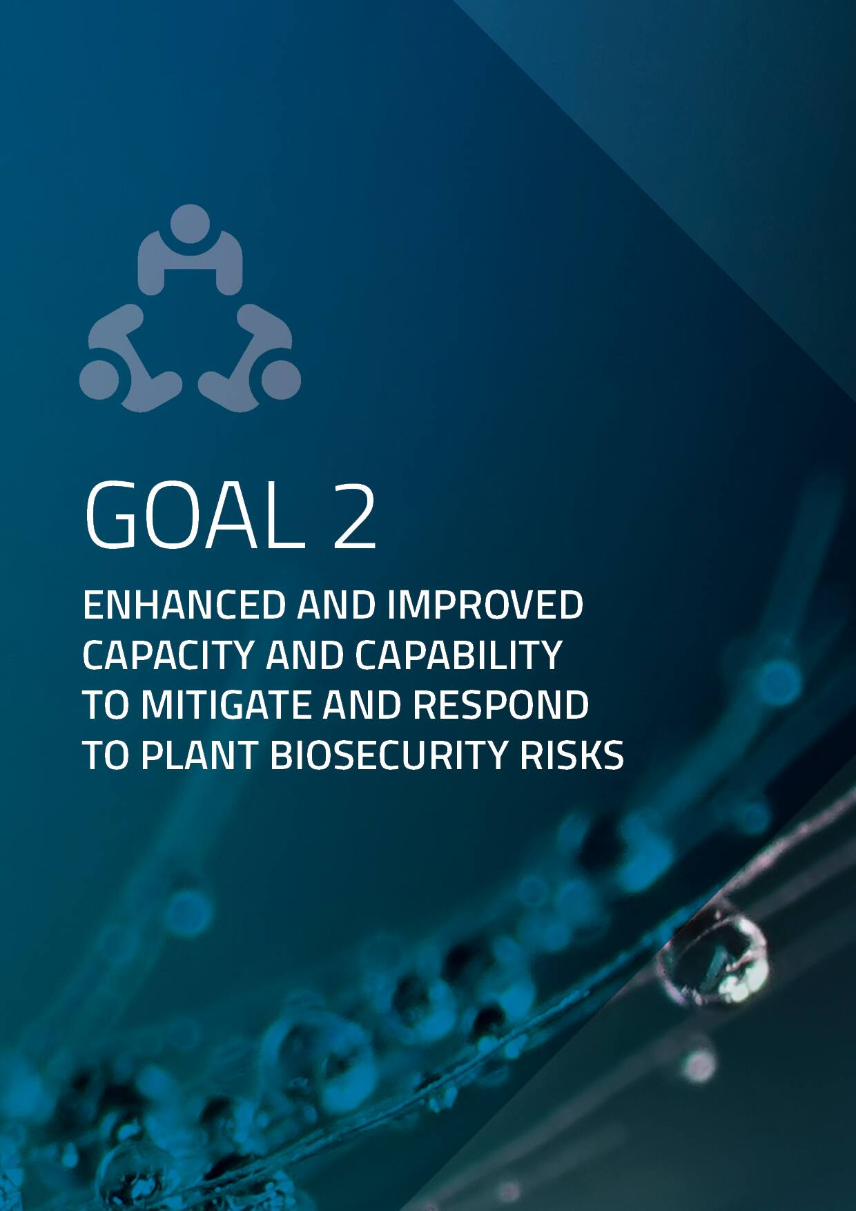

## Expected outcome: Skilled people, contemporary systems and technologies that are prepared to mitigate plant biosecurity risks and are response ready.

### ACTION 2.1:

### Identify and address current and emerging capacity and capability gaps across the national plant biosecurity system

| **Activity** | **Lead/Champion** |
| --- | --- |
| Undertake a review of emerging research for actionable technical components that can integrate into Australia’s National Fruit Fly Management Protocol. | AFFTAC |
| Complete phase 1 of a national emergency preparedness exercise program (Exercise Paratus) and refreshed biosecurity emergency management arrangements. | Australian Government |
| Commence an audit on fruit fly management systems across all jurisdictions. | Australian Government |
| Undertake a comprehensive analysis of national biosecurity RD&E capabilities to identify gaps and address vulnerabilities. | NECBRDES National Coordinator |
| Complete an assessment to identify the critical gaps in preparedness of the top National Priority Plant Pests to assist with the prioritisation of preparedness activities. | Plant Biosecurity Preparedness Working Group |
| Develop a decision tool to assist in identifying which pests will be the target of eradication and which pests will likely be transitioned to management if detected in Australia. | Plant Biosecurity Preparedness Working Group |

### ACTION 2.2:

### Develop and implement tools to improve the detection, identification and prioritisation of plant pests and weeds

| **Activity** | **Lead/Champion** |
| --- | --- |
| Complete the redevelopment of Australia’s National Fruit Fly Management Protocol to improve market access for Pest Free Areas. | AFFTAC |
| Develop delivery guidelines and references covering pre-outbreak, post-outbreak reinstatement and system controls to support Australia’s National Fruit Fly Management Protocol. | AFFTAC – Delivery Guideline Working Group |
| Finalise and implement a national action plan for hitchhiker plant pests to enhance Australia’s capacity to prevent, prepare for and respond to the threat of such pests. | Australian Government |
| Commence development of a national action plan for trees and timber and a national action plan for fruit flies to build national capability to prevent and respond to pest and disease threats. | Australian Government |
| Progress development of a threat abatement plan for myrtle rust to a provide coordinated and long-term national response for current and future threats. | Australian Government |
| Release the Exotic Environmental Pest List Implementation Plan detailing work to continue to reduce the establishing risk of exotic environmental pests, weeds, and diseases. | Australian Government |
| Deliver updates to improve the accuracy and currency of the National Fruit Fly ID Australia website as the nationally recognised tool for fruit fly. | Australian Government |
| Commence development of a national action plan for the management of Phylloxera to raise awareness and improve preparedness for the grape and wine sector. | Australian Grape and Wine |
| Complete a review of the National Wine Biosecurity Strategy and the wine sector biosecurity policy/position statement. | Australian Grape and Wine |
| Finalise the Avocado Industry Biosecurity Strategy 2022-2026. | Avocados Australia |
| Create a national library of data to support the plant health community in preparing, managing and mitigating plant disease outbreaks across Australia’s agricultural sectors. | Bioplatforms Australia |
| Finalise the Citrus Industry Biosecurity Strategy 2022-2027. | Citrus Australia |
| Finalise a National Established Weed Priorities framework and implementation plan to provide a strategic approach for reducing the spread and impacts of established weeds. | EIC - Weeds Working Group |
| Progress efforts to enhance plant pest identification resources that support production nurseries across Australia. | Greenlife Industry Australia |
| Complete a proof-of-concept project using a cloud-based decision support platform (Biosecurity Commons) for modelling and analysing biosecurity risk and response. | Griffith University |
| Develop a cross-strategy framework and supporting extension materials targeted at potential investors to outline shared RD&E priorities. | NECBRDES National Coordinator |
| Develop and implement a New South Wales action plan for fruit flies. | New South Wales Government |
| Develop treatment protocols and risk management advice for the American serpentine leafminer to assist industry and Northern Territory growers. | Northern Territory Government |
| Undertake a targeted risk assessment of invasive ant movement pathways into and within northern Australia. | Northern Territory Government |
| Develop biosecurity plans covering Australia's plant industries that highlight focus areas to improve preparedness for plant pest incursions. | Plant Health Australia |
| Maintain and update the Pest Information Document Database. | Plant Health Australia |
| Progress Panama disease tropical race 4 (TR4) research projects in collaboration with key partners to help the banana industry with future disease management. | Queensland Government |
| Undertake research into the use of fruit fly baits and lures to better inform the use of these tools during a fruit fly outbreak. | South Australian Government |
| Conduct a review of the fundamental principles underpinning the management of Potato Cyst Nematode. | Victorian Government |

### ACTION 2.3:

### Address barriers and establish incentives to improve engagement and the adoption of plant biosecurity practices

| **Activity** | **Lead/Champion** |
| --- | --- |
| Develop a tool to intervene and understand the motivations, barriers and drivers of people who purchase seeds online. | Australian Government |

### ACTION 2.4:

### Develop and deliver training and simulation exercises to test preparedness to biosecurity incidents

| **Activity** | **Lead/Champion** |
| --- | --- |
| Develop eLearning content to improve biosecurity awareness and help support effective responses to plant biosecurity incidents. | Plant Health Australia |
| Deliver industry liaison training workshops in collaboration with state and territory governments. | Plant Health Australia |
| Deliver an Oriental Fruit Fly simulation exercise. | Plant Health Australia |
| Develop a draft resource package/toolkit to support signatories to the Emergency Plant Pest Response Deed to extend training on national arrangements to growers and local industry groups. | Plant Health Australia |
| Develop and deliver a biosecurity response training package suitable for Torres Strait Islanders and Northern Peninsula Area residents who may need to deliver a rapid response in the region. | Queensland Government |

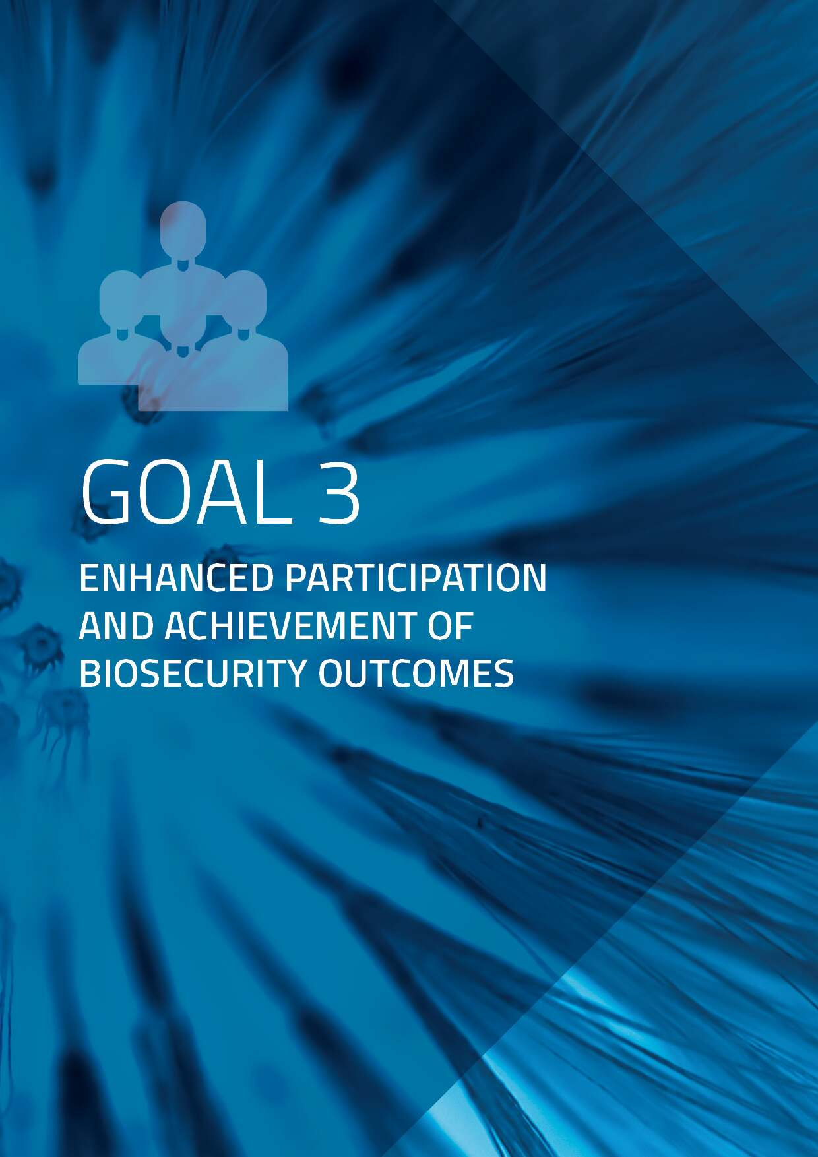

## Expected outcome: Improved participation in preparedness activities through a greater awareness of plant biosecurity risks.

### ACTION 3.1:

### Develop material to promote awareness of obligations and responsibilities of stakeholders across the national plant biosecurity system

| **Activity** | **Lead/Champion** |
| --- | --- |
| Commence work with plant industries to develop a communication plan for the promotion and extension of biosecurity awareness to industry. | Plant Health Australia |
| Deliver an education and awareness campaign around the General Biosecurity Duty. | Various |

### ACTION 3.2:

### Implement national education campaigns to increase awareness of plant biosecurity risks, management actions and the principle of shared responsibility

| **Activity** | **Lead/Champion** |
| --- | --- |
| Develop educational resources for growers about Panama TR4 focusing on surveillance, diagnostics and what to do if TR4 is detected on a farm. | Australian Banana Growers |
| Deliver targeted biosecurity education campaigns, in multiple languages where relevant, including with a focus on online shoppers. | Australian Government |
| Complete delivery of a biosecurity extension project for the melon industry to grow capacity and understanding about on farm biosecurity practices. | Australian Melon Association |
| Progress work to raise awareness of biosecurity risks and increase the adoption of farm biosecurity measures among vegetable and potato growers. | AUSVEG |
| Deliver an extension program to increase awareness, preparedness and recovery support to production nurseries across Australia. | Greenlife Industry Australia |
| Develop a program on plant health and biosecurity for school‑aged children (years 5-6) in New South Wales to raise biosecurity awareness. | New South Wales Government |
| Deliver information sessions aimed at backyard or local growers about the need to control Queensland fruit fly. | New South Wales Government |
| Deliver the National Bee Biosecurity Program to help beekeepers manage pests that are already in Australia and educate and prepare for incursions by exotic pests. | Plant Health Australia |
| Partner with Animal Health Australia to raise awareness and improve the adoption of biosecurity management practices on farms through the Farm Biosecurity Program. | Plant Health Australia |
| Develop a plan for a national approach to acknowledge and celebrate International Plant Health Day across the plant health sector in Australia. | Plant Industries Biosecurity Committee |
| Deliver a school engagement program and community speaking program to promote awareness of the role community can play during an incursion. | South Australian Government |
| Deliver a Biosecurity for Contractors Program for vineyard owners and contractors focused on farm-gate hygiene and biosecurity activities. | Vinehealth Australia |

### ACTION 3.3:

### Support efforts that recognise and celebrate stakeholder contributions to the national plant biosecurity system

| **Activity** | **Lead/Champion** |
| --- | --- |
| Deliver the 2022 Australian Biosecurity Awards to recognise biosecurity champions across industry, government and the public. | Australian Government |
| Support the Ritman Scholarship to recognise students with a commitment to plant health. | Plant Biosecurity Research Initiative |

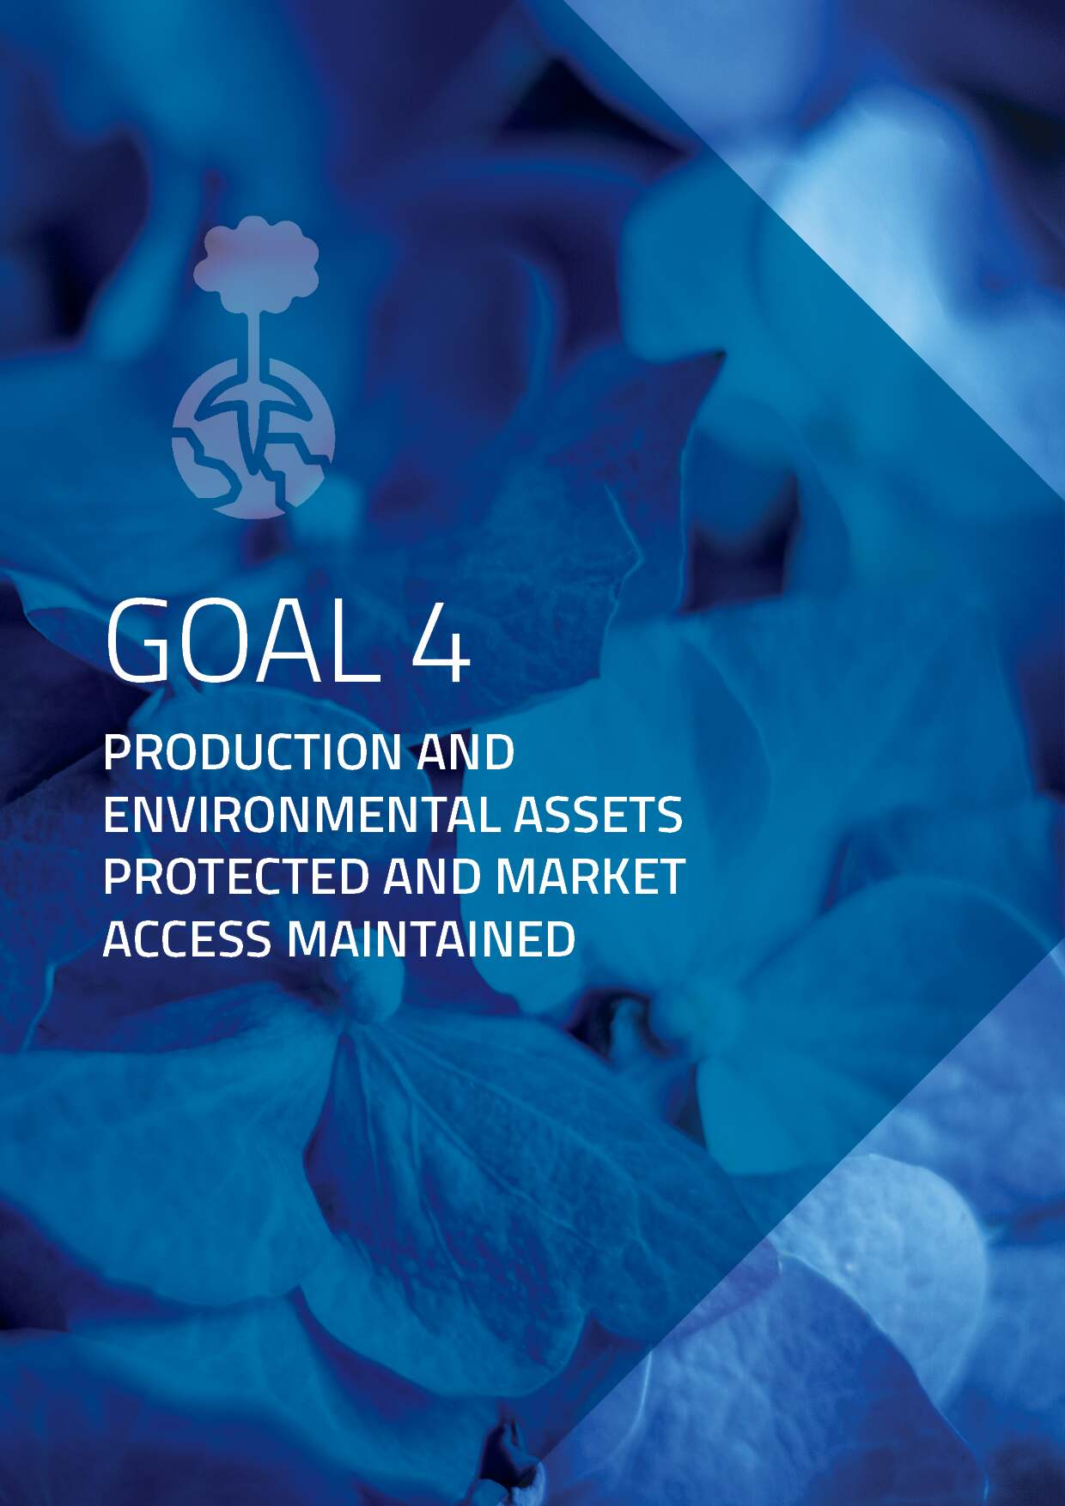

## Expected outcome: Reduced impact of plant biosecurity incursions on the environment, community, trade and market access.

### ACTION 4.1:

### Develop and maintain contingency material and/or environmental asset management plans for plant biosecurity risks

| **Activity** | **Lead/Champion** |
| --- | --- |
| Coordinate the development, management and endorsement of contingency plans for priority plant pests. | Plant Biosecurity Preparedness Working Group |
| Deliver preparedness and contingency planning workshops in the South Australian Riverland and other growing areas to help prepare growers for fruit fly outbreaks. | South Australian Government |

### ACTION 4.2:

### Establish domestic market access arrangements prior to the detection of exotic plant pests

| **Activity** | **Lead/Champion** |
| --- | --- |
| Progress work to establish a Biosecure Hazard Analysis Critical Control Point (HACCP) as a third party plant health accreditation scheme in the Northern Territory. | Northern Territory Government |
| Progress work to develop a National Biosecurity Assurance System to support continued trade in a number of circumstances. | Plant Health Committee |
| Evaluate the most appropriate domestic pest risk analysis framework to support decision-making and market access assessments. | Plant Industries Biosecurity Committee |
| Progress work to address inconsistencies in market access protocols for intra and interstate trade of plants and plant products. | Plant Industries Biosecurity Committee |
| Complete a review of jurisdictional entry requirements reflected in priority documents to support the Interstate Trade System. | SDQMA |
| Progress work on new systems approaches to support trade and help South Australian growers manage fruit fly risks. | South Australian Government |
| Develop an improved set of domestic trade arrangements for Medfly based on the existing Interstate Certification Assurance arrangements that are accepted for Queensland fruit fly. | South Australian Government |

### ACTION 4.3:

### Establish pre-emptive arrangements for the containment and control of exotic plant pests and weeds

| **Activity** | **Lead/Champion** |
| --- | --- |
| Conduct a review of grape phylloxera control orders for Phylloxera Infested Zones and Phylloxera Exclusion Zones. | Victorian Government |

## 

## Expected outcome: Plant industries, the environment and communities recover rapidly and fully after a biosecurity incident.

### ACTION 5.1:

### Develop and maintain a national model for funding recovery efforts for affected communities, businesses, industries and the environment

| **Activity** | **Lead/Champion** |
| --- | --- |
| Commence the development of a national model for funding recovery activities associated with plant biosecurity incursions. | Australian Government |

### ACTION 5.2:

### Develop and maintain capability to provide immediate relief to affected communities, industries and the environment during a response

| **Activity** | **Lead/Champion** |
| --- | --- |
| Commence the development of national recovery principles in collaboration with plant biosecurity stakeholders. | Australian Government |
| Finalise a plan for the transition of Panama TR4 disease management from the Queensland Government to the banana industry. | Queensland Government |
| Develop awareness material to support fruit fly affected communities and industries in South Australia through Phase 2 of the "Restrictions are in place" fruit fly community awareness campaign. | South Australian Government |

### ACTION 5.3:

### Develop national partnership arrangements for responding to Emergency Plant Pests that are not (or unlikely to be) technically feasible to eradicate

| **Activity** | **Lead/Champion** |
| --- | --- |
| Establish an Issue Resolution Group to explore the development of national partnership arrangements for responding to Emergency Plant Pests that are not feasible to eradicate or successful eradication is doubtful. | Plant Health Australia |

1. The lead/champion is the entity, organisation or group responsible for delivery and best placed to provide an update on the progress of an activity.